**CFD ANALYSIS AND EXPERIMENTAL INVESTIGATION OF CI ENGINE USING HYDROGEN WITH DIESEL**

S.PRABHAKAR,V.N.BANUGOAPN,K.ANNAMALAI,S.JAYARAJ,P.SENTILKUMAR

Dept of Automobile Engg, MIT Campus, Anna University-Chennai, Chennai.

*E.mail:* [*ruggers955@yahoo.co.in*](mailto:ruggers955@yahoo.co.in)

**ABSTRACT**

Hydrogen is being considered as a primary automotive fuel and as a replacement for conventional fuels. Some of the desirable properties of like high flame velocity; high calorific value motivates us to use an engine fuel. Most of the combustion features of hydrogen make it a good fuel for internal combustion engines.

A computational model is also being developed and computational fluid dynamic analysis has carried out by using STAR-CD. The mixing parameters like fluid flow, mixing, turbulence and back pressure was analyzed using CFD. Obtained from the theoretical analysis are used for make necessary modifications in the engine.

To prevent the back fire of the flame after the combustion is over from the engine combustion two safety devices will be installed in the system. One is plate type flame trapper and the other one is water based flame arrester. Both of them are connected in series order to prevent backfire.

The experimental investigation is going on a single cylinder 4-S diesel engine, with hydrogen as a fuel. Hydrogen is kept in a cylinder and is inducted by varying the quantity using pressure regulator and a volume flow meter specially made for these purpose. The induction to the engine is a small modification to the intake manifold through which the hydrogen is mixed with inlet air to the engine. Combustion performance and emission parameters will be recorded and analyzed at various flow rates of hydrogen.

**INTRODUCTION**

In the modern and fast moving world, petroleum based fuel have become important for a century’s development. Products derived from crude oil continued to be the major and critical source of energy for fuelling vehicles all over the world. However, petroleum reserves are limited and are non renewable. At the current and projected rate of consumption of crude, it is estimated that these reserves will be badly depleted in due course and it may become impossible to meet the requirements. The demand for petroleum products in 1990-91 was estimated as 58.87 million tones in 2010-2011. Diesel is mainly consumed in the transport, industries and agricultural sectors. The cost of transportation affects the economics of all other consumables that reach common people in a developing country like India. A country’s development is strongly linked to availability of fuels for transportation and power generation. Thus, India faces the major challenges of meeting the high demand of oil to meet the growing energy needs.

It is therefore, important to have long term plane for development of alternative energy sources in balanced manner by making optimal use of available land and manpower resources. It is important to explore the feasibility of substitution of diesel with alternative fuel, which can be produced within the country on a massive scale with for commercial utilization.

At present the potential alternatives are:

* Alcohols (Methanol and Ethanol)
* Liquefied petroleum gas (LPG)
* Compressed natural gas (CNG)
* Hydrogen
* Vegetable oils

**FLOW ANALYSIS OF INLET MANIFOLD NUMERICAL SIMULATIONS**

For the mixing of hydrogen and oxygen in the inlet manifold is analyzed in Computational Fluid Dynamics (CFD) using STAR – CD. The analyzed is made in two possibilities.

**ANALYSIS**

The inlet manifold diameter is maintain constant for reducing losses and hydrogen inlet angle is varied by varying hydrogen nozzle angle with reference to inlet air flow. The analysis is made at various angle of hydrogen inlet angle. The better mixing property of hydrogen and oxygen with less back pressure is found out. The analysis report of various hydrogen inlet angles is shown as follows.

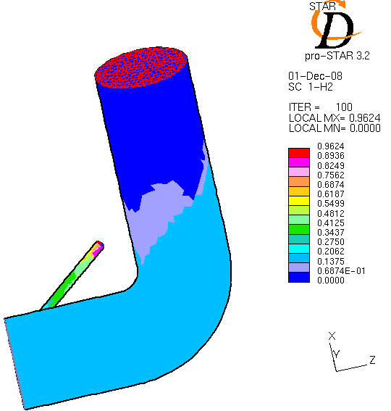

Angle hydrogen distributions in inlet manifold at 40◦

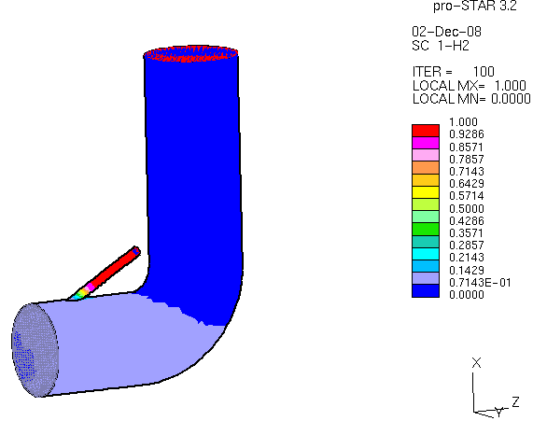

Angle hydrogen distributions in inlet manifold at 30◦

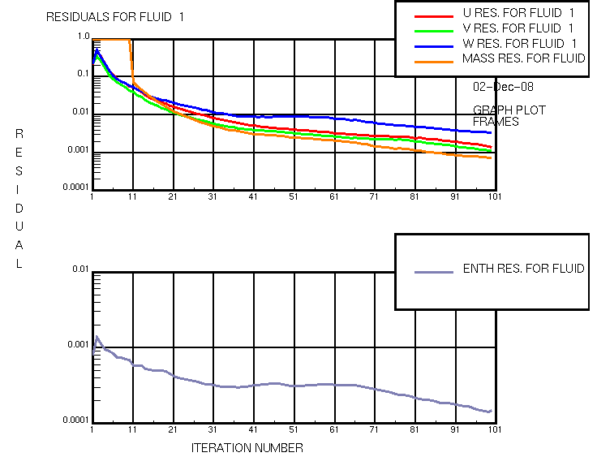

From the above analysis the inlet angle of 30◦ is better compare to other angles. In the hydrogen inlet of 30◦ the back pressure is found to be less and hence the back fire.

So in this project experimental is made as the hydrogen inlet nozzle is fixed at 30◦. The fabrication is made according to that

**EXPERIMENTAL SETUP AND PROCEDURE**

An experimental setup was made with necessary instruments to evaluate the performance, emission and combustion parameter of the compression ignition engine at different operating conditions. The overall view of the engine setup is shown in fig: 1. this chapter discusses the detail of the experimental setup, instruction used and development of certain components and software need for the work.

The engine used for the investigation is a four stroke water cooled single cylinder engine and vertical diesel engine developing a rated power 5.9KW at a rated constant speed of 1600rpm. The engine is coupled with an electrical dynamometer and resistance loading. Fuels like bio diesel used as the pilot fuel in the test engine and the hydrogen is induct through the inlet manifold.

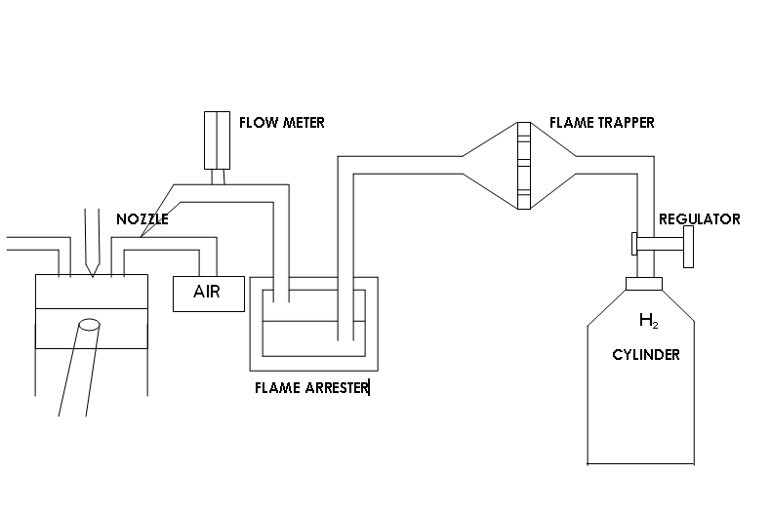

fig: 1 Schematic layout of the experimental setup

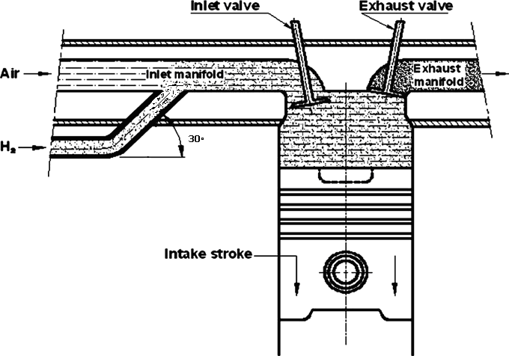

Inlet manifold injection system

A separate induction system was made to supply hydrogen to the engine. It consisted of high pressure gas cylinder, high pressure valve and pressure regulator. Hydrogen was allowed to flow through the pressure regulator where its pressure was reduced to near atmospheric value. The hydrogen gas from the outlet of the pressure regulator was made to flow through a positive displacement gas flow meter. The specifications are given in appendix. Two flame arrestors, one of the water types and the second one based on critical diameter (0.623mm) were fabricated and used in the system to avoid back firing in the line as a safety measure.

These flame arresters operate on the basic principle that thee flame get quenched if sufficient heat can be removed from the gas by arresters. Hydrogen then passed through flame trap, which is used to suppress the flash back if any into intake manifold. It is used to stops the flame by preventing it from reaching the submerged intake.

The hydrogen from the cylinder after passing through the flame trap is induced by two ways.

1. Timed intake port injection technique

2. Timed manifold injection technique

The engine is maintained at constant speed of 1600 rpm at different loads the mass flow of hydrogen is varied.

**RESULTS AND DISCUSSION**

The engine emissions like NOX, HC, CO, and CO2 measured by appropriate instruments. HC, CO, NOX emissions were measured by exhaust gas analyzer. The analyzer was configured to perform a measurement by applying Non dispersive infrared (NDIR) method for analyzing CO, CO2 and HC and electrochemical method for analyzing NOX. The electrochemical method measures the gas density by using the quantity of oxidation reaction of gas. HC and NOX are measured in ppm and CO and CO2 in percentage by volume. Temperature was measured at various point of the test rig like, outlet of the exhaust manifold; inlet and outlet water and exhaust temperature at the calorimeter using a number of temperature sensors which were connected to the data storage display system. The result report of various graphs like performance and emission is shown as follows.



Fig. 4.1 Variation of brake thermal efficiency with load



Fig 4.2 Variation of specific energy consumption with load



Fig 4.3 Variation of oxides of nitrogen with load



Fig 4.4 Variation of smoke with load



Fig 4.5 Variation of hydro carbon with load



Fig 4.6 Variation of carbon monoxide with load



Fig 4.7 Variation of carbon dioxide with load

**CONCLUSION**

Experiments were conducted to study the performance and emissions characteristics of a diesel engine using hydrogen gas by means of inlet manifold induction techniques with diesel. Based on the experimental study the following conclusions are drawn:

1. The brake thermal efficiency of hydrogen with diesel increased when compared to base diesel fuel.
2. The specific energy for duel fuel mode was reduced by 24% compared to base diesel 25% load.
3. There was 13% increase in NOX while using hydrogen with diesel as ignition source, which is higher than base diesel fuel.

**REFERENCES**

1. B.Haragopala Rao, K.N. Shrivastava and H.N. Bhakata, “Hydrogen for duel fuel engine operation”, International journal of hydrogen energy, vol.8.
2. Bertrand D.Hsu, “Practical diesel engine combustion analysis” by Bertrand D.Hsu, society of Automotive Engineers, Inc. 2002.
3. J.A. Cston, “An investigation of cause of backfire and its control due to creviced volumes in hydrogen fueled engine” Transactions of ASME vol. 23.
4. J.D. Naber and D.L. Siebers, “Hydrogen combustion under diesel engine condition”, International journal of hydrogen energy, vol. 23.
5. L.M. Das, “Near – term introduction of hydrogen engines for automotive and agricultural application” international journal of hydrogen energy, vol. 27.
6. S.J. Lee, H.S.Yi, and E.S. Kim, “combustion characteristics of intake port injection type hydrogen fuelled engine”, International journal of hydrogen energy, vol. 20.
7. N. Saravanan and G.Nsgarajan “Performance and emission study in manifold hydrogen injection with diesel as an ignition source for different start of injection” from science direct web site.